# Trial Data Analysis for GEF Carbon Sampling Methodology Design

Dugal Harris 27 Oct 2017

This document presents the results of a data analysis exercise conducted on the GEF 2017 field trial data. As part of the trial, allometry was conducted for all plant species in five plots. Two plots were located in degraded thicket and three in intact thicket. Allometric models for thicket species were obtained from Marius van der Vyver. Where there were measurement records for species that hadn't yet been identified, an allometric model for what is assumed to be a similar species was used. E.g. for "Asparagus hairy", the "Asparagus capensis" model was used.  No obvious species choice could be made for some of these unidentified measurement records. The records for these cases formed a small portion of the total and were omitted from the analysis.

## Woody Canopy

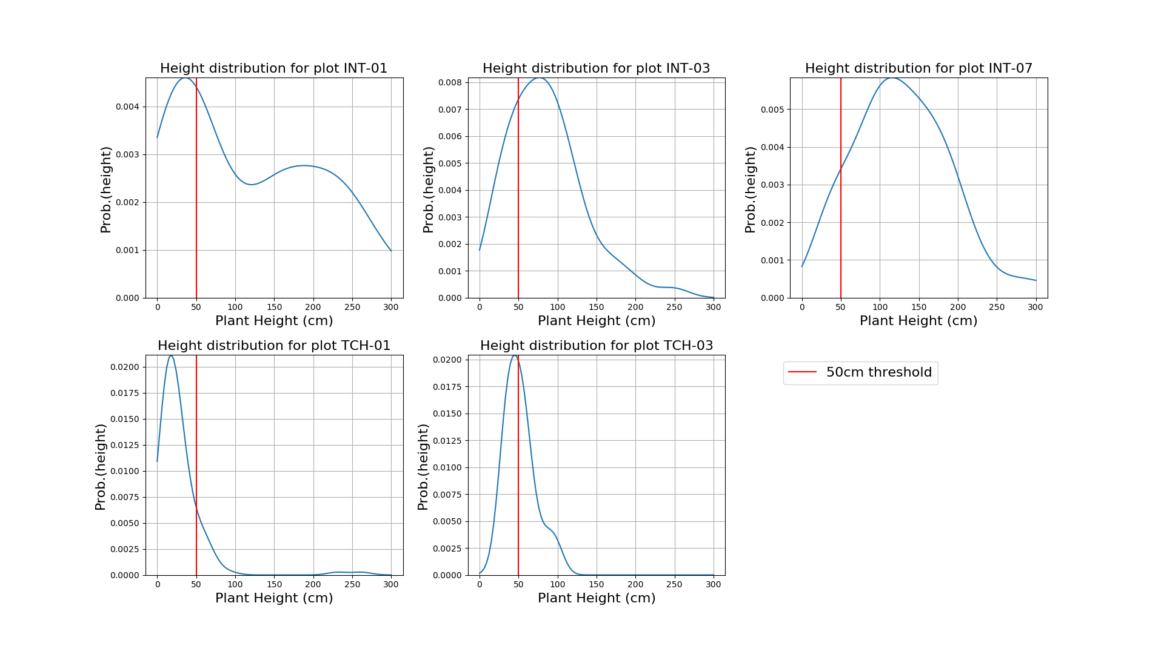

Figure 1 Height distributions per plot

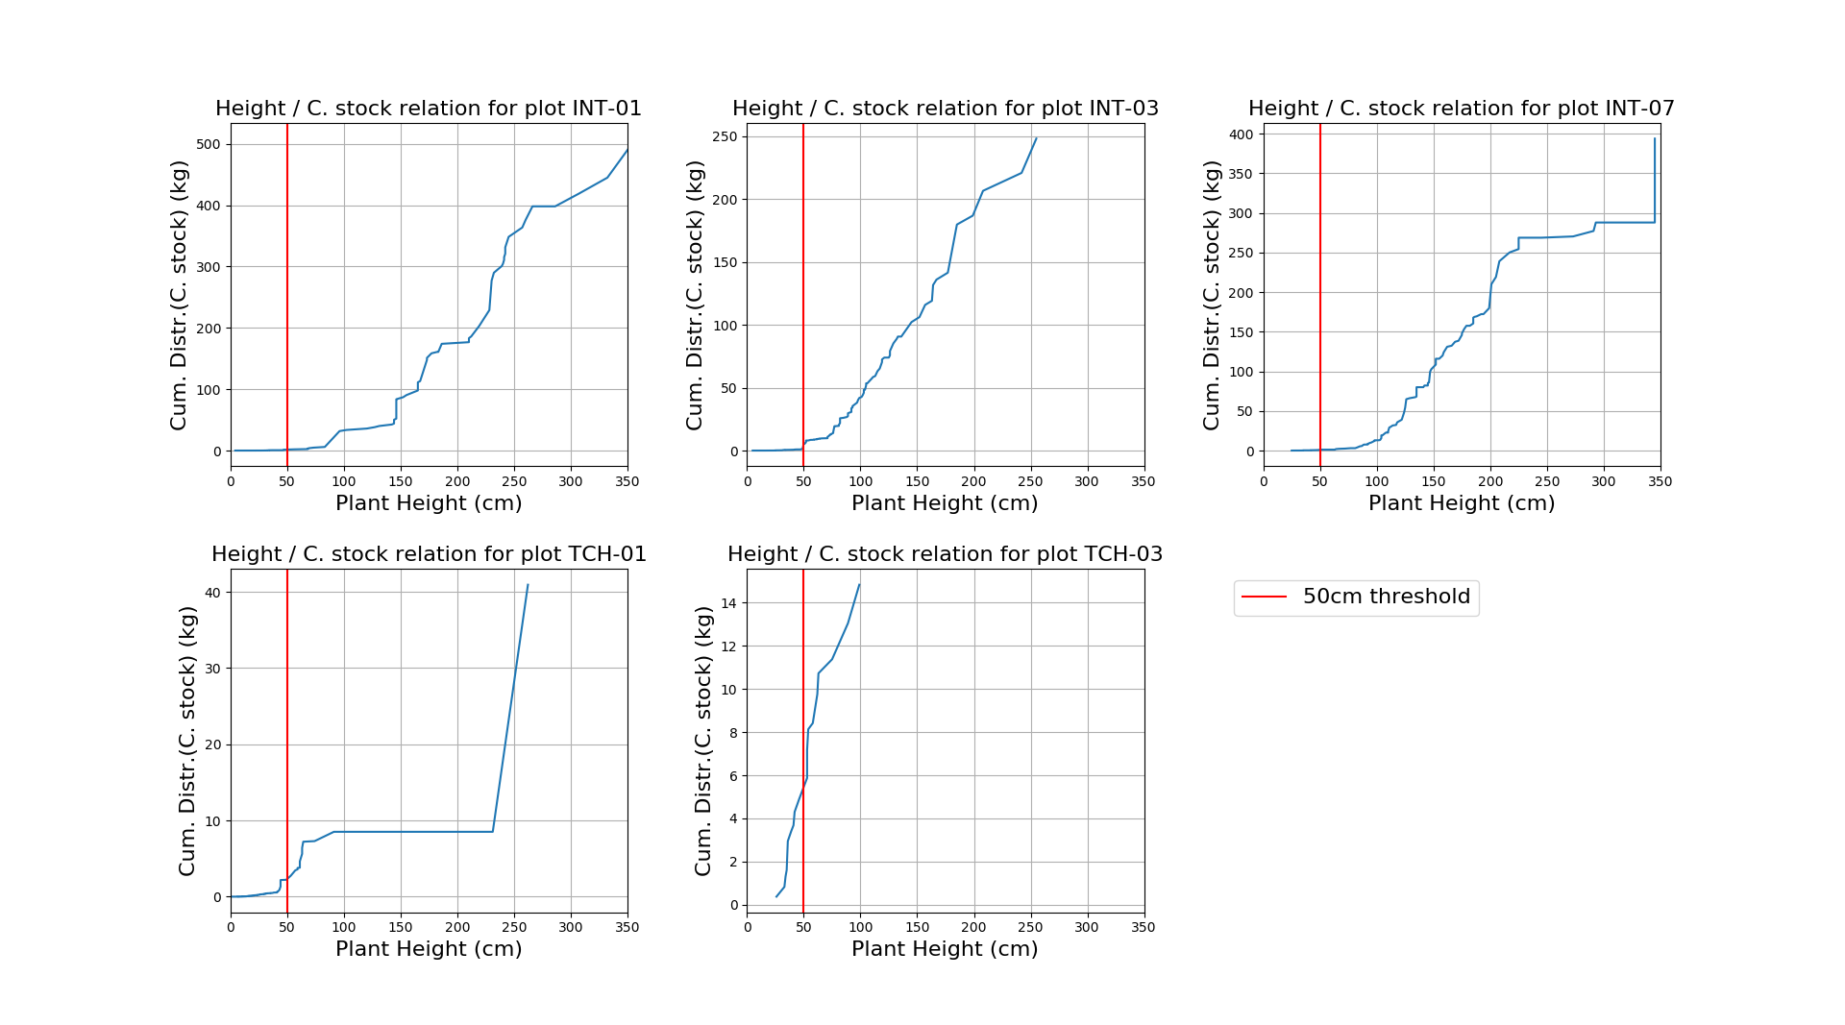

Figure 2 Carbon stock cumulative contributions by plant height

Figure 1 and Figure 2 are intended to inform the design of nested plots with a possible plant threshold height. Figure 1 shows the plant height distribution for each plot. These are kernel density estimates (KDE).  Plants under 50cm comprise a substantial portion of the records.  Figure 2 shows the quantity of carbon contributed by plants of different heights.  These graphs display the cumulative carbon contributions ordered by plant height for each plot.  For all plots except TCH-03, the carbon contributed by plants with heights under 50cm makes a very small contribution to overall carbon.  For TCH-03, these smaller plants contribute about 40% of the total carbon. This plot, however, has the lowest total carbon overall, meaning the 40% contribution is relatively insignificant in terms of total carbon.  I believe these results support the use of a nested plot design.  While plants under 50cm form a substantial portion of the measurements, they contribute very little to total carbon. I suggest using a 5x5m nested plot, where all plants are measured, and then only measuring plants taller than 50cm in the rest of the containing plot.  The carbon for plants under 50cm in the 5x5m nested plot can be extrapolated to the containing plot.  The 5x5m size is a loose recommendation and could perhaps be made smaller.  This analysis suggests the nested plots will be beneficial for both degraded and intact plots. Practically, however, it may not be easy to quickly judge plant height in dense intact thicket.

Plot

yAA

xA

AText

Ellipse section A

(xA + yA) / 2

Circular approximation B

Figure 3 Edge intersected canopy area and approximation

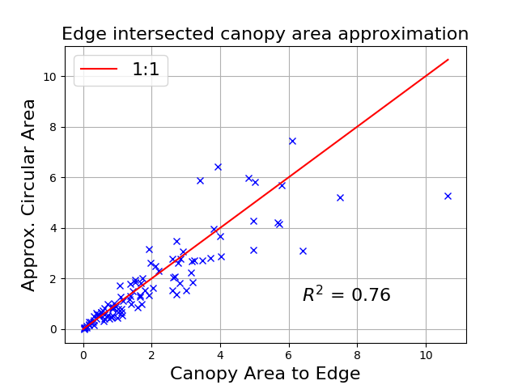

Figure 4 Edge intersected canopy area approximation

Figure 3 and Figure 4 give a rough indication of how well canopy area can be approximated with a modified allometry approach, for the special case of plant canopy overlapping the plot boundary.  Figure 3 defines the areas being measured and approximated. Actual canopy is modelled by an ellipse that intersects the plot boundary to give the elliptical section area A. This area is approximated by the circular area B, which is effectively the standard allometric approach used in Marius’ models. A number of randomly sized and positioned ellipses were generated and their corresponding intersected areas calculated as indicated in Figure 3. Figure 4 shows a scatter plot of area A versus the approximated area B for these ellipses. I think these results indicate that the approximation is acceptable.

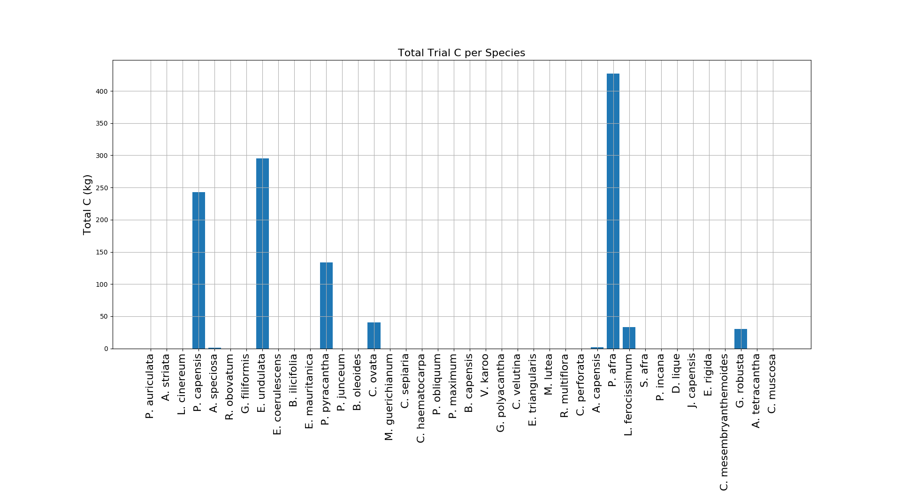

Figure 5 Total carbon per species over all plots

Figure 5 shows the total carbon contributed by each species over all of the trial plots. The four biggest contributors are *P. afra, E. undulata, P. capensis* and *P. pyracantha*.

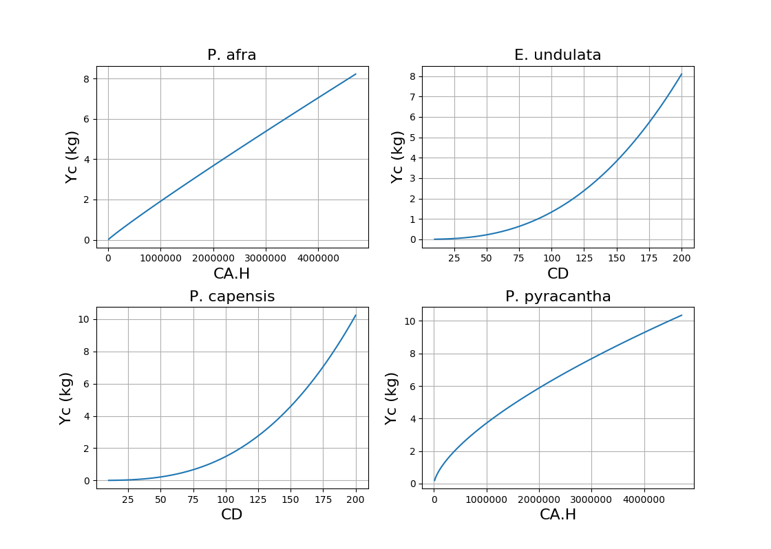

Figure 6 Carbon Vs allometry for key species

Figure 6 shows how carbon (*Yc*) varies with the allometric measure (*x*) for each of the four key species’ allometric models. See Marius’ allometry table for further details of the models and their parameters. This plot was produced to give an indication of how linearly or otherwise carbon scales with plant dimension. It is (questionably) useful for informing the decision of how to treat plants overlapping the canopy boundary. E.g. if half the plant is overlapping and is measured, do we expect to get half the carbon from the allometric model?

My preference for treatment of plants overlapping the plot boundary is to measure them as indicated in Figure 3. These results somewhat support this approach. I believe the strongest reason for this approach over others is a more conceptual one i.e. for degraded plots, containing possibly one or two large trees, it is likely to give the most accurate results. This is because it represents an appropriate portion of each tree rather than omitting or excluding it entirely.

## Dead Wood

Lying dead wood carbon stocks were estimated with Equation 6 from the CDM AR-Tool12 document (<https://cdm.unfccc.int/methodologies/ARmethodologies/tools/ar-am-tool-12-v3.0.pdf>). Standing dead wood measurements were treated as lying dead wood and modelled as such with Equation 6. It was not possible to apply specific CDM standing dead wood models, as only line transect diameter measurements were made during the trial (these models require height and stem diameter measurements to be made for dead wood inside the plot boundaries from what I can tell). The “default” carbon estimation approach of Equation 9 could not be tested as no default factor is provided for appropriate arid habitats (see Section 8.1, Table 5).

The fixed parameters in Equation 6 were set as follows:

|  |  |  |
| --- | --- | --- |
| **Parameter** | **Description** | **Value** |
|  | Sample plot area (ha) | (10x10)/(100x100) |
|  | Carbon fraction of tree biomass (dimensionless) | 0.48 (from M. Powell’s dissertation) |
|  | Basic wood density for species *j* (t d.m.m-3) | 0.5 (estimate from M. can der Vyver’s dry-wet ratios for all species) |
|  | Sum of lengths of the transects (m) | 100 |
|  | Density reduction factor for nth piece of wood (dimensionless) | 1 for solid  0.8 for intermediate  0.45 for rotten |